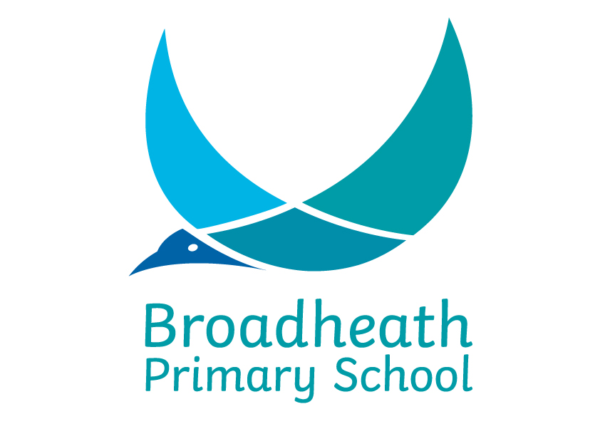
Sinderland Road, Broadheath, Altrincham, Cheshire WA14 5JQ
Telephone: 0161 928 4748
e-mail: broadheath.admin@trafford.gov.uk
www.broadheathprimaryschool.com
Headteacher: Mrs K Lyde

NURSERY APPLICATION FORM

Date Received:

Child’s Surname: | First Name:
Middle Name(s):

Male/Female: | DOB:

Child’s Home Address:

Post Code:

Home E-mail Address:

Contact: *delete as appropriate
Name: |  |  | Mr/Mrs/Miss/Ms/Dr*
Relationship to pupil:
Address:
Main Contact Please tick:
Mobile/home number:
Work number:

Preferred 1st and 2nd option for your child – please mark accordingly
*Full Time | 8:45 – 3:30
Monday | 8:45 – 11.45
Afternoon | 12:45 – 3:30

Additional Information
Do any other children living at the same address already attend the school. If yes please complete the details below:

Childs surname | First name | Class

Additional Support  Does your child receive any support e.g. Speech & Language Therapy | Yes | No
If yes, please give details:

Special Educational Needs:

Note: Parents should note that there can be no guarantee of a place in the main school as a result of a child attending the Nursery class. Reception applications should be processed through Trafford Council School Admissions via their online Parent Portal.

Signature of Parent/Carer:

Please print your name

Your relationship to the child

Todays date

* FOR THE ATTENTION OF ALL PARENTS/CARERS OF CHILDREN WHO HAVE BEEN ALLOCATED / ARE LOOKING FOR A FULL TIME PLACE – THIS SECTION MUST BE COMPLETED
For 30 funded hours, eligible parents must ensure that they have an ‘active’ 11 digit eligibility code in place at the beginning of each term. The current eligibility criteria can be found on Trafford Council’s website.

Should your child be allocated a full-time position, please indicate below how you would settle your child’s account:

I will have an active eligibility code |  | Privately funding for the additional 15 hours (£15.00 per session – subject to change)

Should my child be offered a full-time place, I can confirm that I will take responsibility to keep my eligibility code renewed every three months, in addition I hereby confirm that I will pay the lunch time cover fee subsidy of £3.00 per session via my online Arbor account.

If I choose to privately fund the additional 15 hours, I agree to pay £15.00 per session (subject to change) in addition to the lunch time cover fee of £3.00 per session via my online Arbor account.

Please note - Should the code not be renewed for any reason the 15 hours fee becomes the sole responsibility of the Parent/Carer.

Please sign below to agree to the terms and conditions PARENT/GUARDIAN
Sign: | Print Name:

