|  |  |  |  |  |
| --- | --- | --- | --- | --- |
|  | **Week 1** | **Week 2** | **Week 3** | **Week 4** |
| **Monday** | BBQ Chicken Wrap Or Sweet Chilli Quorn Wrap both served  with Savoury Rice & Mixed Vegetables  Ice-Cream Roll | Mac & Cheese served with Garlic Bread & Peas  Or Vege Samosa served with Savoury Rice & Peas  Strawberry Ice-Cream | Beef or Quorn Burger with Potato Wedges & Beans  Vanilla Ice-Cream | Cheesy Tomato Pasta with Garlic Bread  Or Corn & Broccoli Parcel with Saute Potatoes & Sweetcorn  Chocolate Ice-Cream |
| **Tuesday** | Meat & Potato Pie served with Crusty Bread  Or Cheese Swirl with Saute Potatoes & Sweetcorn  Shortbread | Chicken or Vege Meatballs both served with Pasta & Sweetcorn  Chocolate Crispy | Pork or Vege Sausage Roll both served with Diced Potatoes & Beans  Chocolate Chip Cookie | Chicken or Quorn Taco with Peppers, Onion & Tomatoes served with Rice & Mixed Vegetables  Apple Crumble & Custard |
| **Wednesday** | Chicken or Quorn Roast Dinner both served with  Roast Potatoes, Carrots, Gravy & Yorkshire Pudding  Chocolate Cake | Cottage Pie or Cheese & Onion Flan both served with Carrots & Crusty Bread  Raisins | Turkey or Quorn Roast Dinner both served with  Roast Potatoes, Carrots, Gravy & Yorkshire Pudding  Party Cake | Pork or Vege Sausage served with Mashed Potato, Carrots and Gravy  Scone & Jam |
| **Thursday** | Chilli Con Carne or Vege Chilli served with Rice & Sweetcorn  Ginger Biscuit | Sweet & Sour Chicken or Quorn both served with Noodles & Mixed Vegetables  Vanilla Sponge | Chicken Tikka Massala Or Chickpea & Lentil Tikka Massala Served with Rice, & Naan Bread  Coconut Biscuit | Beef or Vege Bolognese served with Sweetcorn & Garlic Bread  Angel delight |
| **Friday** | Fish Finger Wrap with Chips & Peas Or Cheesy Tomato Pasta with Garlic Bread  Lemon Drizzle Cake | Fish Fingers or Pizza Whirl both Served with Chips & Peas  Lemon Shortbread | Fish Finger Butty with Chips & Peas  Or Cheesy Tomato Pasta with Garlic Bread  Flapjack | Fish Fingers Or Cheese & Tomato Pizza both served with Chips & Peas  Chocolate Shortbread |

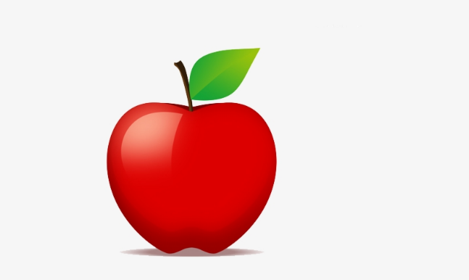**School Lunch Menu**

|  |  |
| --- | --- |
| **Every Day** | Jacket Potato with either Beans, Cheese, Tuna Mayo or Cheesy Beans + Access to Salad Bar |
| **Every Day** | Ham Roll, Tuna or Cheese Sandwich all served with Cucumber + Access to Salad Bar |
| **Every Day** | Fresh Fruit or Yoghurt |