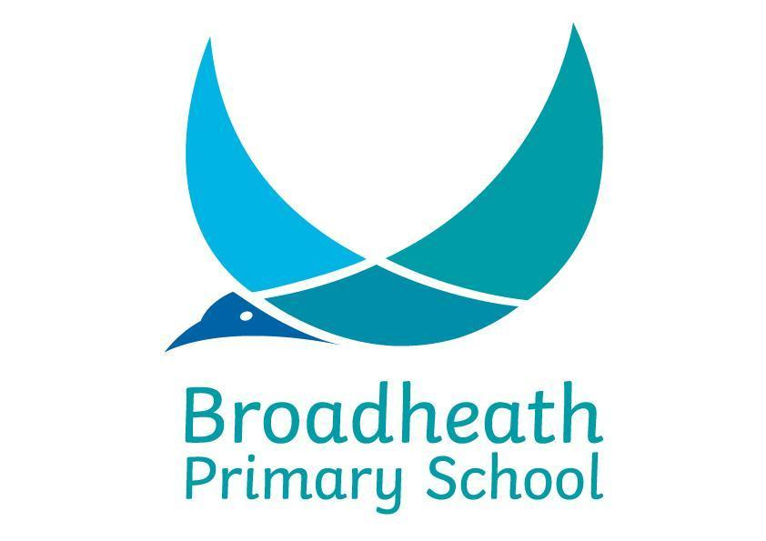
Curriculum map 2020-2021 Year: Two Class: 2R 2S

Maths | Curriculum 2014  Y2 programme of study – White Rose Maths Hub (Updated version for 20-21)  https://www.gov.uk/government/publications/national-curriculum-in-england-mathematics-programmes-of-study/national-curriculum-in-england-mathematics-programmes-of-study
English | NARRATIVE  Wild  Meerkat Mail | NON-FICTION  Instruction writing | TRADITIONAL POETRY  The Owl and the Pussycat  Limericks | NON-FICTION  Recount and explanation GFoL | NARRATIVE  The Baker’s Boy and the GFoL | POETRY  Jelly Boots, Smelly Boots-  Michael Rosen | NARRATIVE  Hodgeheg  Fantastic Mr Fox | POETRY  Performance Poetry- Julia Donaldson | NON-FICTION  Non-Chron reports- Rainforests
Theme | Habitats | Famous Nurses |  | The Great Fire of London |  | Let’s Let Loose ! | Amazing Animals | Rainforests
Drivers | Science  Living things and their habitats  Linda Brown Buck  (Biologist) | History  Famous Nurses  Mary Seacole and male nurses |  | History  The Great Fire of London  Percy L. Julian (invented ‘bean soup’ WW2) |  | English  Michael Rosen Poetry  Stephen Wiltshire (artist) | Science  Animals including humans  (Animals focus) | Geography  Kampong Ayer  Ade Adepitan (author/presenter/paralympian)
Enhancers | English  See above  Art  Printing  Geography  Oceans and continents +  map/field work  PE  Under the Sea | English  See above  Science  Animals including humans  (Humans focus)  DT  Textiles, templates and joining |  | English  See above  Science  Materials  DT  Fire Engines-  Wheels and axels |  | Art  Drawing and Painting  Science  Working Scientifically  Music  I wanna play in a band | English  See above Computing  Creating Pictures  Art  Use of ICT  Music  Zoo Time  (African Music) | English  See above  DT  Fruit kebabs  Science  Plants  Computing  Presenting Ideas
Discreet | PE – Invasion Games  Computing – Online Safety and Effective searching  Music – Charanga: Hands, Feet, Heart  PSHE –Mental Health  +  Bouncing Back  RE – Islam 1.2: Who is Muslim and what do they believe? | PE – Movement Skills  Gymnastics  Computing – Coding  Music – Christmas songs  PSHE – SRE (Y1 focus)  +  More Than One Friend  RE – How and why do we celebrate special and sacred times? |  | PE –Great Fire of London Dance  +  Movement Skills 3  Computing – Questioning  +  Making Music  Music – Friendship song  PSHE – Bullying and Saving Energy  RE – Who is Jewish and what do they believe? |  | Computing – Spreadsheets  PSHE – Africa and To give is to receive  RE – Who is Jewish and what do they believe?  PE – Net and Wall Games 2  +  Gymnastic skills 2 | RE – 1.4 What can we learn from sacred books?  PSHE –It’s a dog’s life and The Golden Statue  RE – 1.4 What can we learn from sacred books?  PE – Athletics  +  Striking and Game skills 3 | RE – 1.4 What can we learn from sacred books?  PE –Target games  +  Gymnastics  Music – Reflect, Rewind and Replay  PSHE –SRE: Healthy Lifestyles week  +  Vote for the GoGivers

