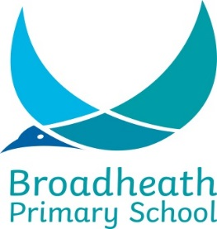

SCHOOL HOLIDAY YEAR SEPTEMBER 2020 / JULY 2021

TERM | SCHOOL OPENS 8.55 am | SCHOOL CLOSES 3.20 pm
Autumn 2020 | Wednesday 2nd September | Friday 23rd October
 | HALF TERM
 | Tuesday 3rd November | Friday 18th December
Spring 2021 | Tuesday 5th January | Friday 12th February
 | HALF TERM
 | Monday 22nd February | Thursday 1st April
Summer 2021 | Wednesday 14th April | Friday 28th May
 | HALF TERM
 | Monday 14th June | Wednesday 21st July

Staff Training Days:

Tuesday 1st September 2020
Monday 2nd November 2020
Monday 4th January 2021
On Monday 3 May all schools will be closed for the early May Bank Holiday.
Thursday 22nd July 2021
Friday 23rd July 2021

