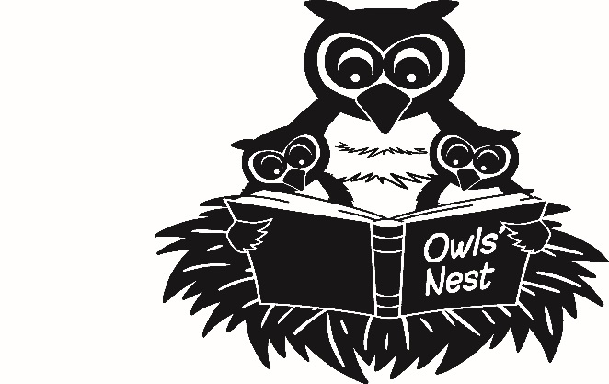

OWLS’ NEST
PAYMENT DETAILS

As there will not be any invoices issued, Parents/Carers are responsible to book and pay for the spaces as detailed in the terms and conditions. Please note that refunds will not be given where cancellation is given with less than 48 hours notice. Fees are due to be paid the first week back.

Option 1- When paying by Bank Transfer,
please see our bank details below, followed by the detail required for referencing:-

SORT CODE NUMBER | 30 – 90 – 16
ACCOUNT NUMBER | 16367960
ACCOUNT NAME | BROADHEATH PRIMARY SCHOOL

- ON for Owls’ Nest only / EB for Early Birds only and ONEB for both Owls’ Nest and Early Birds, followed by your child’s surname.
- You may only make one payment for both sessions providing the number of sessions you have used both Owls’ Nest and Early Birds for are exactly the same.
- Alternatively you must pay separately, with the same reference coding please as detailed above.
- Please add a 2 if you are paying for 2 siblings at the same time.

Option 2 - When paying by child care vouchers,
please advise us of the details of the company that you are using if you have not done so already.

Option 3 - When paying by cash /cheque:-
Please make cheques payable to Broadheath Primary School.
Place the payment in an envelope.
Please mark the envelope with:-
- Your child’s name
- Class
- Amount enclosed
- Clearly mark Owls’ Nest only, Early Birds only or both (ONEB) for both Owls’ Nest and Early Birds.

