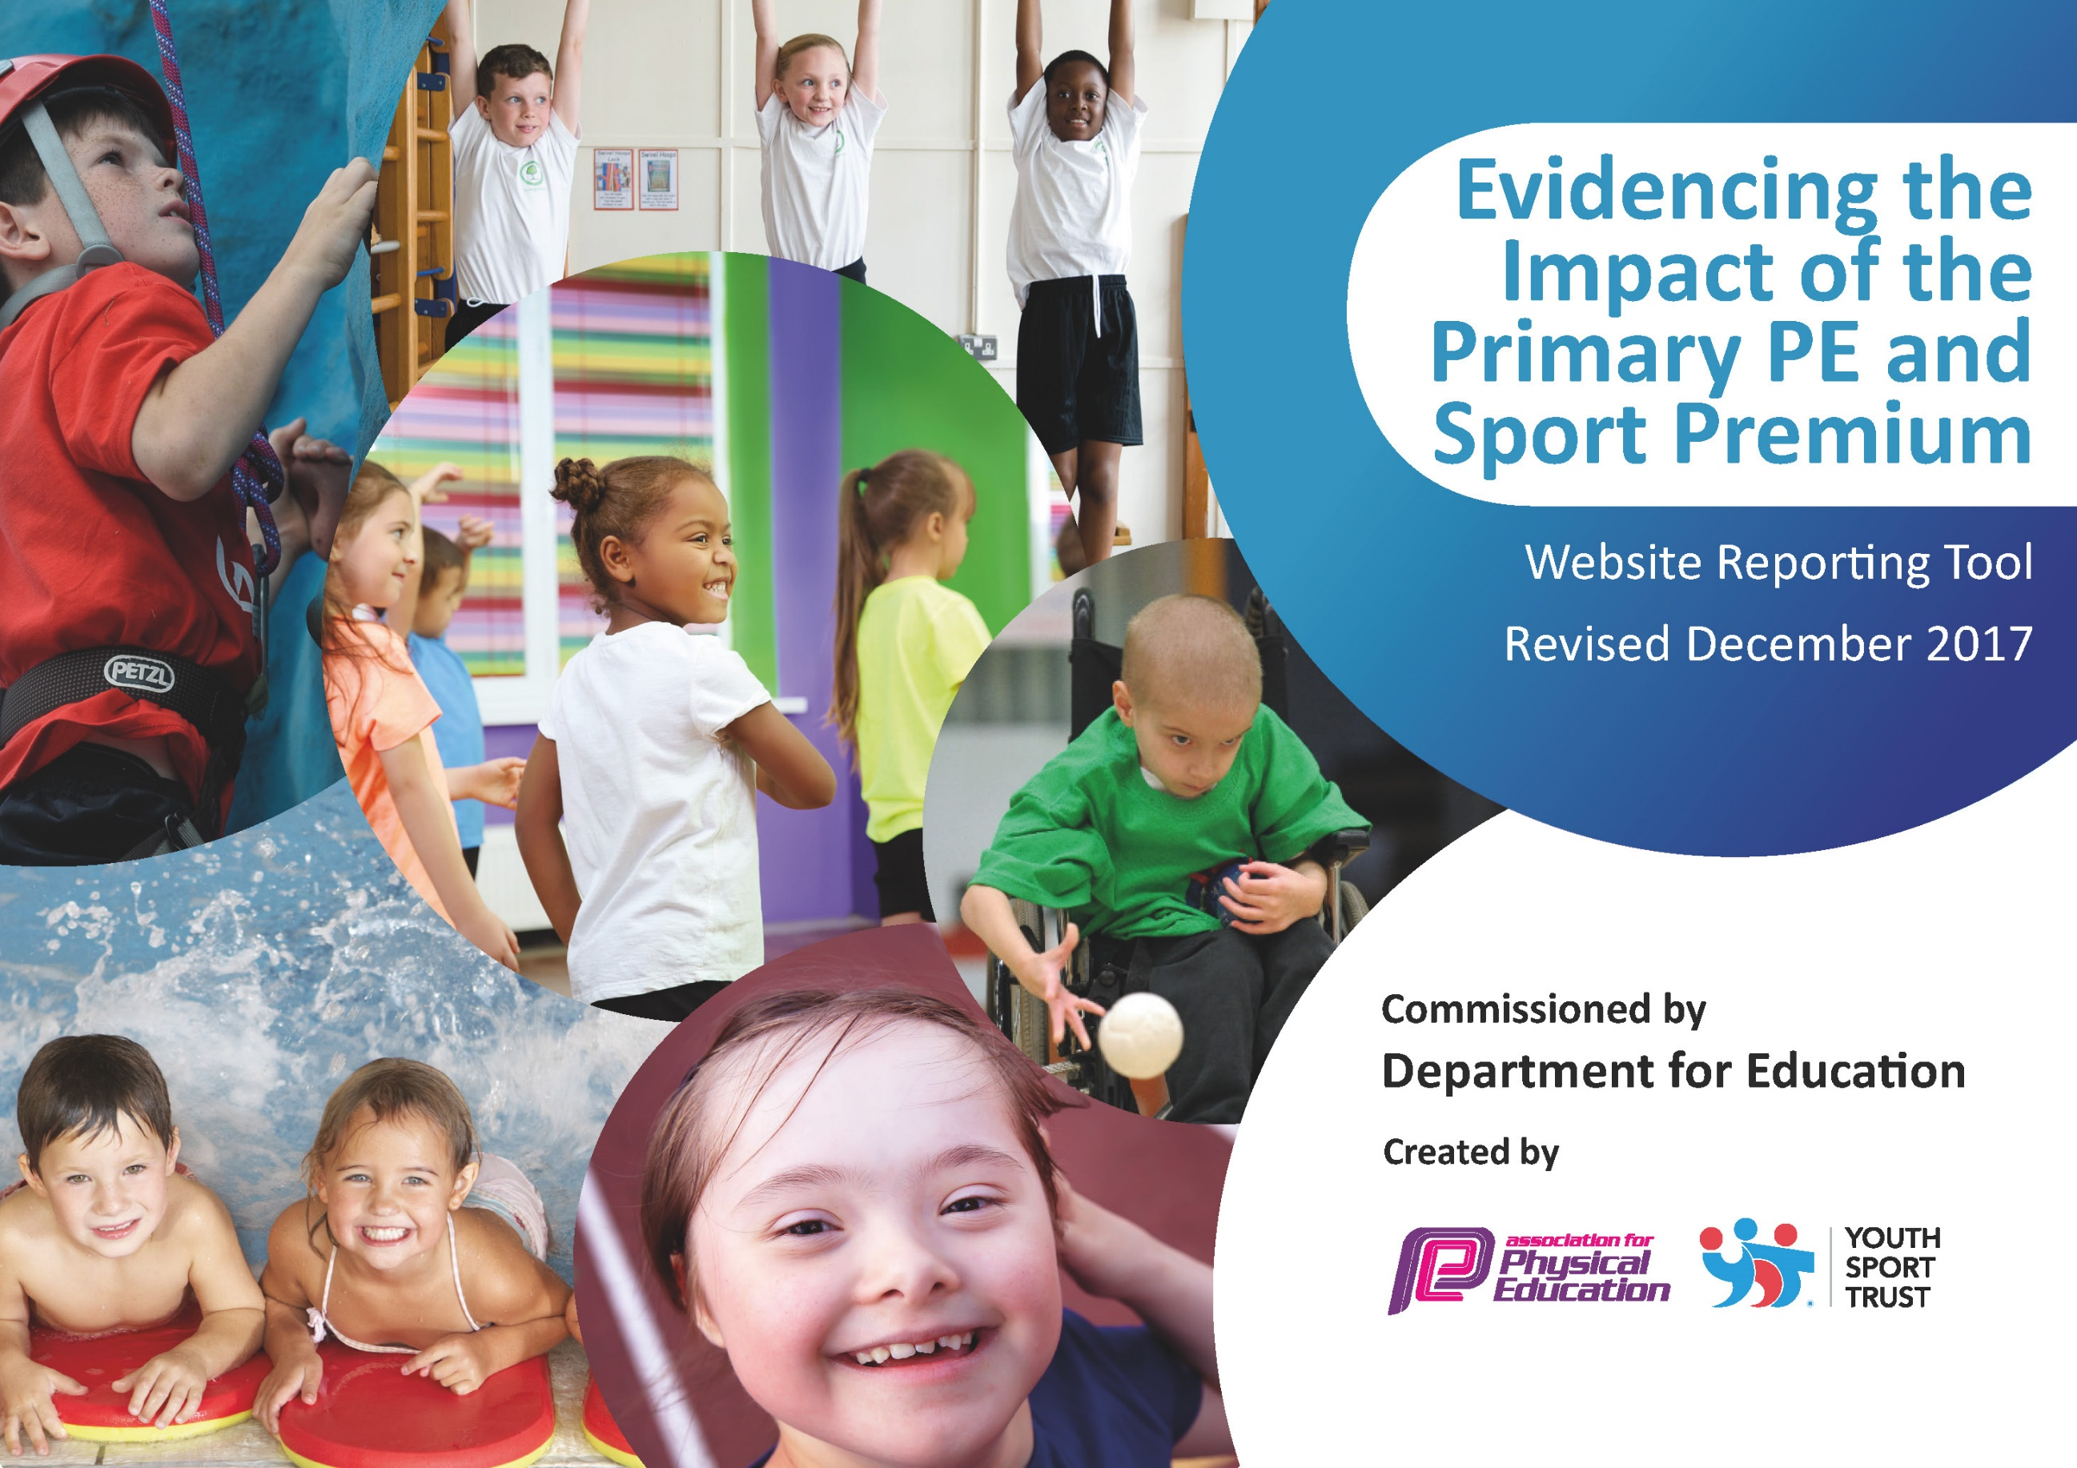

Broadheath Primary School

Schools must use the funding to make additional and sustainable improvements to the quality of PE and sport they offer. This means that you should use the Primary PE and Sport Premium to:

- develop or add to the PE and sport activities that your school already offers
- build capacity and capability within the school to ensure that improvements made now will benefit pupils joining the school in future years

Schools are required to publish details of how they spend this funding as well as on the impact it has on pupils’ PE
and sport participation and attainment.

Key achievements to date: | Areas for further improvement and baseline evidence of need:
- High quality teaching and learning taking place during PE sessions and throughout the school day taught by staff and specialist coaches – leading to children receiving 2 hours of PE per week.  - New equipment bought and accessible for chn to use at break times and lunchtimes.  - Increased participation in intra/inter school competitions  - Increased percentage of chn across KS1/KS2 representing the school in a wide range of sports.  - Wide offer of sports clubs before, during and after school for children to take part in.  - Sports leaders actively leading/organising games at breaktime and lunchtimes and promoting healthy, active lifestyles  - Funding for pupil premium pupils targeted to attend clubs  - Mindfulness clubs started for KS1 children  - Maths Of The Day introduced – active lessons and outdoor learning part of whole school development plan  - On-going use of the PE passport providing staff with high quality planning and detailed assessment opportunities  - Introduction of the daily mile  - Installation of a new running track  - SGM GOLD achieved for the third consecutive year | - Continue to provide further opportunities for staff to engage in training  - Continue to develop and encourage more ‘active’ hands-on, active learning across KS1/KS2  - Further develop the well-being of staff and children through activities such as Yoga.  - Continue a holistic approach to PE - offering a range of activities.  - Ensure all children are able to swim 25 metres competently by the end of Year 6.  - Continue to identify those children not taking part in any extra-curricular clubs and provide them opportunities.  - Continue to identify children to provide opportunities for competitive sport.

Meeting national curriculum requirements for swimming and water safety | Please complete all of the below*:
What percentage of your current Year 6 cohort swim competently, confidently and proficiently over a distance of at least 25 metres? | 87.25%
What percentage of your current Year 6 cohort use a range of strokes effectively [for example, front crawl, backstroke and breaststroke]? | 82.42%
What percentage of your current Year 6 cohort perform safe self-rescue in different water-based situations? | 82.42%
Schools can choose to use the Primary PE and Sport Premium to provide additional provision for swimming but this must be for activity over and above the national curriculum requirements. Have you used it in this way? | Yes/No  ** Will be using some funding to support those who aren’t able to yet swim 25m competently.

Action Plan and Budget Tracking
Capture your intended annual spend against the 5 key indicators. Clarify the success criteria and evidence of impact that you intend to measure to evaluate for students today and for the future.

Academic Year: 2018/19 | Total fund allocated: £19,120 | Date Updated: 25.7.19
Key indicator 1: The engagement of all pupils in regular physical activity – Chief Medical Officer guidelines recommend that primary school children undertake at least 30 minutes of physical activity a day in school |  |  |  | Percentage of total allocation:
 |  |  |  | 87.9%
School focus with clarity on intended impact on pupils: | Actions to achieve: | Funding allocated: £16838 | Evidence and impact: | Sustainability and suggested next steps:
Funded specialised coaching from:  Extra-Time LTD  Timperley boxing club  Altrincham FC  Timperley Bootcamp  Sports breakfast clubs – ExtraTime  SB Playground Leader training  Maths Of The Day scheme of work introduced and rolled out across KS1/KS2 to develop active learning  Installation of a new running track to carry out the ‘Golden mile’ daily  Source new equipment to aid introduction of new sports to engage less active children  Use sports funding to put towards the cost of a new running track | To deliver excellent coverage of a wide range of sports and activities during curriculum time  Additional curriculum opportunities:  Sale Sharks  Man Utd Football  Altrincham FC  All classes to use scheme of work to deliver active lessons  Identify course on the field  Seek quotes for running track from local ground companies to advise of cost etc. Create plan of action for this process.  Audit equipment across KS1/KS2 for lunchimte provision/teaching of PE  Exteranl coaches run bootcamp  Ensure equipment easily accessible  Provide staff with Questionaire re equipment needed  Involve sports leaders in development of games and sports | Specialist sports coaches: £9,251  £695  £6,000 *subsidised from last years budget/main budget  £892.15 | Specialised coverage/provision in all aspects of the PE curriculum from EYFS – KS2  Continued specialised provision of a high standard with increased numbers of pupils engaging in extra-curricular provision  Chn taking active role in lessons and are challenged physically and mentally. Concentration improved as a result  Promotion of health and well-being increased  Increased levels of physical activity and raised attainment in maths  All pupils carry out daily mile every day – so all involved in extra activity  Area always used for ‘personal best’ challenges  New running track huge success – chn excited to use daily  Audit showed need for new equipment to introduce new games/sports  Equipment bought covered a range of activity including net and wall, invasion and personal best  Wider impact/result:  Pupils more active in PE lessons and generally throughout the school day – there are more opportunities for chn to be active  Standards improving across KS1/KS2  PE valued across school and attitudes in all subjects improving as a result | Teachers work closely alongside external specialist coaches to upskill PE teaching and learning.  Staff to promote health and well-being through promotion of clubs, high-quality PE, active lessons and the daily mile  Next steps:  Develop area in playground for chn to use equipment eg monkey bars etc  Develop active scheme of work for English  Teaching staff continue to carefully monitor progress through use of assessment tools and % of chn in classes attending extra-curricular clubs  PE Homework  Each key stage to be set homework tasks on the school website every half term/ focus on personal best
Key indicator 2: The profile of PE and sport being raised across the school as a tool for whole school improvement |  |  |  | Percentage of total allocation:
 |  |  |  | 2.1%
School focus with clarity on intended impact on pupils: | Actions to achieve: | Funding allocated: £386.20 | Evidence and impact: | Sustainability and suggested next steps:
Promote achievements of all PE/sport related activity in our celebration assemblies to raise the profile of involvement in sport and inspire peers to take up sport  Increase number of children representing the school through competition  Ensure a PE notice board is accessible and on display for all to see to raise the profile of leading a healthy, active lifestyle  Promote successes through use of specialised stickers and certificates in celebrations | Share achievements in praise assemblies with the whole school  Share successes in newsletters and through social media outlets (including sporting achievements outside of school for local clubs)  PE displays managed and updated regularly throughout the year  Increase participation numbers at competitions by entering more teams thus increasing number of pupils involved  Enter A, B and C teams in a range of competitions for KS1 and KS2 children where possible | Transport costs: £386.20 | 2 teams entered into 7 different competitions  Notice boards relevant and current – provide all with current initiatives on-going in schools.  Children have enjoyed taking part and sharing their achievements  Social media outlets and newsletters regularly update the school and local community.  Improved performances from teams resulting in:  Winners of Altrincham Cup  Winners of 5 a side competitions  Children enjoy sharing success with peers  Inclusion games have been attended by children with SEND and we have entered a range of comps with different chn  In a number of sports we entered A and B teams and in one competition we also entered a C team  Increased pupil participation at events and clubs  Confidence and self-esteem increased due to promotion of successes | Senior management see relevance of funding for transport to allow opportunities for events/competitions  Promote opportunities for competitive sport in KS1 and allowing more children to participate in any given opportunities  Add PE outcomes/achievements to PTFA boards and onto school website  Sports leaders continue to monitor and promote Sport and physical activity throughout school.

Key indicator 3: Increased confidence, knowledge and skills of all staff in teaching PE and sport |  |  |  | Percentage of total allocation:
 |  |  |  | 10.3%
School focus with clarity on intended  impact on pupils: | Actions to achieve: | Funding  allocated:  £1975 | Evidence and impact: | Sustainability and suggested  next steps:
Improve progress and  achievement of all pupils by  up-skilling staff and providing new resources.  Employ specialist coaches to work alongside staff and support delivering high-quality PE  Use new scheme of work for PE to endorse excellent planning and assessment opportunities.  Provide IT equipment (Ipads) for all year groups to use as a tool for planning, assessment and collating of evidence during PE lessons  Buy into MOTD scheme of work | Ensure all identified staff are  enrolled.  Identify dates when cover is  required and provide cover staff.  Ensure that time is provided for  school based working.  To ensure that planning and attendance is recorded and monitored carefully via ipads  Database maintained on PE passport for assessment purposes and accessible to all staff  Undertake all training which is  offered through the sports  partnership/YST and any other accredited organisations with an aim to get more staff up-skilled in a range of activities.  Mapping of school (orienteering coordinates)  Deliver MOTD training for all staff | £1,350  (Membership to  Trafford Sports  Partnership.)  Scheme of work/assessmenttool: £400.00  Orienteering resources  £225.00  MOTD scheme of work (cost above) | Planning has enabled staff to run through PE lessons with high-quality activities and a useful tool for assessment. This has resulted in increased confidence of staff delivering lessons.  Increased confidence and better  subject leadership skills enabling  the subject leader to support  and facilitate learning for all staff.  Teachers and PE coaches have a better understanding of NC objectives/outcomes – progression monitored more carefully and effectively | Increase data collection/evidence impact information  More opportunities for staff to attend CPD courses  Continue to provide CPD support through TSP and other outlets to ensure all teaching staff can confidently and indepdently deliver the PE curriculum to a high standard
Key indicator 4: Broader experience of a range of sports and activities offered to all pupils |  |  |  | Percentage of total allocation:
 |  |  |  | See above
School focus with clarity on intended  impact on pupils: | Actions to achieve: | Funding  allocated: | Evidence and impact: | Sustainability and suggested  next steps:
Continue to offer and differentiate the range of different sports activities on offer to children before, during and after school.  Encourage and support those chn who do not engage in extra-curricular activity. | C4life club offered to targeted children  Carry out a pupil audit to identify what sports children partake in outside of school and also what clubs they would like to have the opportunity to access as extra-curricular clubs.  Undertake all training which is  offered through the sports  partnership/YST and any other accredited organisations with an aim to get more staff up-skilled in a range of activities.  Support of external coaches to deliver new clubs | See Key indicator 1 for coaches costs etc  See Key indicator 3 for TSP cost annually. | More staff involved in  extracurricular activities and new equipment provided to enhance experiences children have.  7 new clubs on offer: table tennis, Archery, tag rugby, Yoga, Tri-golf, Street Dance, Boxing  A wider range of sporting competitions have been entered with consideration given to chn that partake in sports outside of school and those who haven’t had the opportunity to represent school before. | Teaching staff continue to be enthused to deliver 2 hours of PE per work and are equipped with the necessary tools to ensure high-quality learning.  Staff work together to share good practice  Staff keen to ensure a minimum of two hours PE is taught per week  Continue to organize level 1 competitions and where possible – host level 2 competitions  Continue to enter a wide range of sports that provide ALL children with the opportunity to compete
Key indicator 5: Increased participation in competitive sport |  |  |  | Percentage of total allocation:
 |  |  |  | See above
School focus with clarity on intended  impact on pupils: | Actions to achieve: | Funding  allocated: | Evidence and impact: | Sustainability and suggested  next steps:
To introduce and offer competitive  sports opportunities that we have not  previously competed in.  Engage more pupils in inter/intra  school competitions; ensure those who  are disengaged are involved and enthused.  Increase the number of children attending extra-curricular clubs to promote and engage sporting activities | Arrange friendly competition between ourselves and other school s in the local area -  intra/inter school opportunities – TSP  Money allocated to fund transport  Join additional competitions eg  Basketball, Athletics, Tri-Golf, Athletics, Orienteering, Swimming Gala  Provide an abundance of opportunity for children to access a range of sporting activities regularly throughout the school day . Furthermore, offer a range of extra-curricular opportunities.  Staff members to work with and alongside Sports Coaches to implement and  develop skills in added sports. | See above for transport costs | All of KS2 provided with opportunity to participate in intra-school competition and all chn engaged in intra-competitions  KS1/KS2 children have had opportunity to represent the school in different events  We have entered 12 different sporting competitions this year  Number of girls and boys of different age ranges representing the school for the first time has risen by 50%  Number of children representing the school at competition this year has more than doubled – partly due to us taking more than 1 team to events and also due to entering more competitions  More children have aspirations to represent the school teams and as a result a higher turnout is evident at our clubs | Staff to take sports teams to events  Increase number of girls attending extra-curricular clubs and build links with local community clubs in order for them to access sports eg Sale Cricket Club  Members of staff to manage and coach teams
Further key information:
Clubs without attached funding costs are supported via main school budget
Action plan to be put in place to support those who aren’t yet able to swim 25 metres to ensure all chn are given every opportunity to meet target in timeframe available

