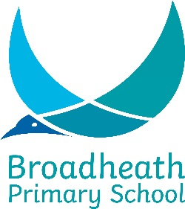
Key Stage Performance Data
2019 Headlines

Reception
80% Good Level of Development National 71.7%/Local 74.4%)

Year 1
Phonics Check- 85% (National 82% / local 85.3%)

Key Stage 1
Emerging National/Local comparisons 2019 in brackets
Maths 79.8% (75.7%/79.8%) 31.5% Greater Depth (21.7/25.7%)
Writing 66.3% (69.3%/72.1%) 13.5% Depth (14.7/16.3%)
Reading 74.2% (75%/79.1%) 27.0% Greater Depth (25/29.2%)

Combined Reading/Writing/Maths 60.7% (65%/68.7%)
Combined Reading/Writing/Maths GD 13.5% (11.2%/13%)

Key Stage 2
Figures in brackets- national/local outcomes 2019.

Writing 82.7% (78%/84.3%) 22.7% Higher Standard (%/26.1%)
Maths 94.6% (79%/87.1%) 57.3% Higher Standard (%/42.2%)
Reading 88.0% (73%/82.7%) 46.7% Higher Standard (%/37.2%)
GPS 94.6% (78%/86.3%) 48.0% Higher Standard (%/47.3%)

Combined Reading/Writing/Maths 80% (65%/75.9%)

Combined Greater Depth 20% (9.9%/17.3%)

Average scaled scores (nat 2018/loc 2019)
2019 Reading- 108 (105.1/106.8)
2019 Maths – 109.7 (104.4/107.7)
2019 GPS- 109.1 (106.2/108.8)

Progress Scores (nat 2019/loc 2019)
2019 Reading +2.7% (0/+1.69)
2019 Writing +0.05 % (0/+0.82)
2019 Maths +3.86% (0/+1.37)

Updated 10th July 2019

