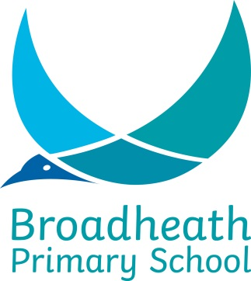
SCHOOL HOLIDAY YEAR SEPTEMBER 2019 / JULY 2020

TERM | SCHOOL OPENS 8.55 am | SCHOOL CLOSES 3.20 pm
Autumn 2019 | Tuesday 3rd September | Friday 18th October
 | HALF TERM
 | Tuesday 29th October | Friday 20th December
Spring 2020 | Monday 6th January | Friday 7th February
 | HALF TERM
 | Monday 17th February | Friday 27th March
Summer 2020 | Tuesday 14th April | Friday 22nd May
 | HALF TERM
 | Monday 8th June | Thursday 23rd July

Staff Training Days:

Monday 2nd September 2019
Monday 28th October 2019
Friday 3rd January 2020
PLEASE NOTE THE SPRING BANK HOLIDAY FOR THIS YEAR ONLY IS ON THE ‘FRIDAY’ 8TH MAY DUE TO VE DAY.
Friday 24th July 2020
Monday 27th July 2020

