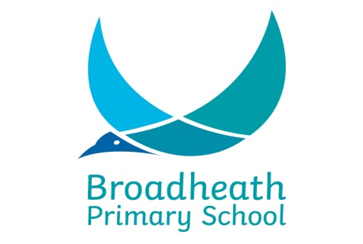

Equality Objectives – 2016 – 2019

There are a number of statutory duties that must be met by every school in line with legislation from the Race Relations (Amendment) Act (2000), Disability Equality Duty (2005) and Equality Act (2010).
Broadheath Primary School is committed to meeting its public sector duties and acknowledges that we have a statutory duty to:

Eliminate discrimination, harassment and victimisation.
Promote equality of access and opportunity within our school and within our wider community.
Promote positive attitudes to difference and good relationships between people with different backgrounds, genders, cultures, faiths, abilities and ethnic origins.

The Leadership Team and Governors at Broadheath Primary School regularly review the progress we are making to meet our equality objectives with regard to the protected groups (race, disability, gender, gender re-assignment, age, pregnancy and maternity, marital status, sexual orientation, religion and belief and sexual orientation) under the Equality Act (2010).

In our review of 2016/17 objectives we recognised the good and outstanding progress made by our EAL pupils across school and so will monitor this to ensure consistency but change focus to a different group of children as outlined below.

Equality Objectives

At Broadheath Primary School, we are committed to ensuring equality of education and opportunity for all pupils, staff, parents and carers, irrespective of race, gender, disability, belief, religion or socio-economic background.

In order to further support pupils, raise standards and ensure inclusive teaching, we have set ourselves the following objectives:-

• To narrow any gaps in attainment and progress that arise between groups of pupils within the school’s community by ensuring that all groups and individuals have their needs fully met in order to achieve their full potential, and to make good progress or better. Particular focus should be placed on children identified as disadvantaged.
• To promote spiritual, moral, social and cultural development through a rich range of experiences both in and beyond the school, with particular reference to issues of equality and diversity. To ensure respect and tolerance for diversity in culture and religion whilst promoting British Values across Key Stages.

