

**Reading**

* Read some common irregular words.
* Use phonic knowledge to decode regular words & read aloud accurately.
* Identify rhymes and alliteration.
* Join in with rhyming patterns.
* Read & understand simple sentences.
* Demonstrate understanding when talking with others about what they have read.
* Make basic predictions.
* Identify start and end of a sentence.

**Writing**

* Write simple sentences which can be read by themselves & others.
* Use capital letters and full stops to demarcate sentences.
* Write demarcated sentences.
* Use correct pencil grip.
* Write name (correct upper & lower case).
* Use correct letter formation for familiar words.



**Mathematics**

* Count reliably to 20.
* Order numbers 1 – 20.
* Say 1 more/1 less to 20.
* Add & subtract two single digit numbers.
* Count on/back to find the answer.

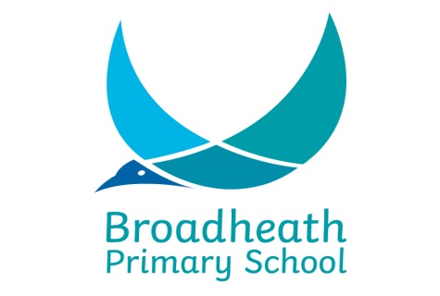

**End of Year Expectations**

**for Reception**

This booklet provides information for parents and carers on the end of year expectations for children in our school. The staff have identified these expectations as being the minimum requirements your child must meet in order to ensure continued progress throughout the year.

All the objectives will be worked on throughout the year and will be the focus of direct teaching. Any extra support you can provide in helping your children to achieve these is greatly valued.

If you have any queries regarding the content of this booklet or want support in knowing how best to help your child please talk to your child’s teacher.