

Broadheath Primary School

Schools must use the funding to make additional and sustainable improvements to the quality of PE and sport they offer. This means that you should use the Primary PE and Sport Premium to:

- develop or add to the PE and sport activities that your school already offers
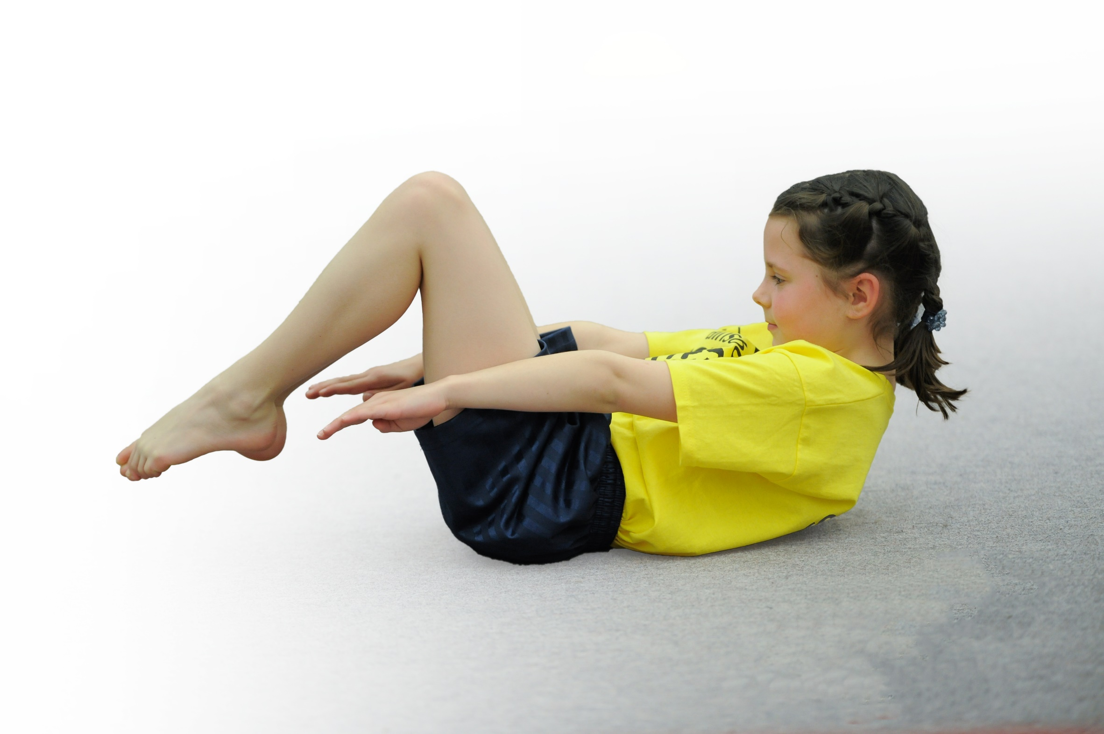
- build capacity and capability within the school to ensure that improvements made now will benefit pupils joining the school in future years

Please visit gov.uk for the revised DfE guidance including the 5 key indicators across which schools should demonstrate an improvement. This document will help you to review your provision and to report your spend. DfE encourages schools to use this template as an effective way of meeting the reporting requirements of the Primary PE and Sport Premium.

We recommend you start by reflecting on the impact of current provision and reviewing the previous spend.
Under the Ofsted Schools Inspection Framework, inspectors will assess how effectively leaders use
the Primary PE and Sport Premium and measure its impact on outcomes for pupils, and how effectively governors hold them to account
for this.

Schools are required to publish details of how they spend this funding as well as on the impact it has on pupils’ PE
and sport participation and attainment.
We recommend regularly updating the table and
publishing it on your website as evidence
of your ongoing review into how you are using the money
to secure maximum, sustainable impact. To see an example of how to complete the table please click HERE.

Support for review and reflection - considering the 5 key indicators from DfE, what development needs are a priority for your setting and your students now and why? Use the space below to reflect on previous spend, identify current need and priorities for the future.

Key achievements to date: | Areas for further improvement and baseline evidence of need:
- High quality teaching and learning taking place during PE sessions and throughout the school day taught by staff and specialist coaches – leading to children receiving 2 hours of PE per week.  - New equipment bought and accessible for chn to use at break times and lunchtimes.  - Increased participation in intra/inter school competitions  - Increased percentage of chn across KS1/KS2 representing the school in a wide range of sports.  - Offer of sports clubs before, during and after school for children to take part in.  - Sports leaders actively leading/organising games at breaktime and lunchtimes and promoting healthy, active lifestyles  - Sports leaders selling fruit at breaktime to encourage healthy eating.  - Introduction of the PE passport providing staff with high quality planning and detailed assessment opportunities  - Introduction of the daily mile | - Provide further opportunities for staff to engage in training  - Encourage more ‘active’ classrooms across KS1/KS2  - Ensure all children are able to swim 25 metres competently by the end of Year 6.

Meeting national curriculum requirements for swimming and water safety | Please complete all of the below*:
What percentage of your current Year 6 cohort swim competently, confidently and proficiently over a distance of at least 25 metres? | 76.42%
What percentage of your current Year 6 cohort use a range of strokes effectively [for example, front crawl, backstroke and breaststroke]? | 76.42%
What percentage of your current Year 6 cohort perform safe self-rescue in different water-based situations? | 71.42%
Schools can choose to use the Primary PE and Sport Premium to provide additional provision for swimming but this must be for activity over and above the national curriculum requirements. Have you used it in this way? | Yes/No  ** Will be using some funding to support those who aren’t able to yet swim 25m competently.
*Schools may wish to provide this information in April, just before the publication deadline.

Action Plan and Budget Tracking
Capture your intended annual spend against the 5 key indicators. Clarify the success criteria and evidence of impact that you intend to measure to evaluate for students today and for the future.

Academic Year: 2017/18 | Total fund allocated: £19,120 | Date Updated: 03.04.18
Key indicator 1: The engagement of all pupils in regular physical activity – Chief Medical Officer guidelines recommend that primary school children undertake at least 30 minutes of physical activity a day in school |  |  |  | Percentage of total allocation:
 |  |  |  | 71.35 %
School focus with clarity on intended impact on pupils: | Actions to achieve: | Funding allocated: £13,643.81 | Evidence and impact: | Sustainability and suggested next steps:
Funded specialised coaching from:  Soccerwise  Timperley boxing club  Altrincham FC  Cirkids  To introduce Stretch-N-Grow to work with our EYFS team to develop key fundamental movement skills  Continue to sustain interest for a range of sports clubs before school  Roll out the daily mile across ks1/ks2 to ensure all children are active for 15 minutes a day  Continue to undertake wake up shake up every day through use of sports leaders  Source new equipment to aid introduction of new sports to engage less active children  Use sports funding to put towards the cost of a new running track  Continue with sports breakfast clubs every day  Train middays/sports leaders effectively to support playground leaders in running activities | To deliver excellent coverage of a wide range of sports and activities during curriculum time  Additional curriculum opportunities:  Sale Sharks  Man Utd Football  Altrincham FC  Stretch-N-grow staff to develop curriculum map and work with EYFS staff and pupils to develop key skills  Range of sports/clubs on offer before, during and after school  Identify course on the field  External coaches to run breakfast clubs  Use funding to buy Archery/tri-golf and table tennis equipment  Seek quotes for running track from local ground companies to advise of cost etc. Create plan of action for this process.  CPD opportunity through Kikstart for middays to develop knowledge of a range of games to support leaders in running activities at lunchtimes | Specialist sports coaches:£4281.00  Resources costs:  £1250.31  Committed: £8000 towards new running track on school field  Kikstart training: £112.50 | All pupils involved in 25 minutes of extra activity every day  Midday assistants increased competence supporting lunchtime activities – more confidence delivering activities  Development of pupil leadership through games/ WUSU  Specialised coverage/provision in all aspects of the PE curriculum from EYFS – KS2  Increased participation numbers of chn in extra-curricular clubs | Teachers work closely alongside external specialist coaches to upskill PE teaching and learning.  Next steps:  Introduce Maths of the Day to ensure being ‘active’ is incorporated into the curriculum.  Teaching staff carefully monitor progress through use of assessment tools  PE Homework  Each key stage to be set homework tasks on the school website every half term/ focus on personal best
Key indicator 2: The profile of PE and sport being raised across the school as a tool for whole school improvement |  |  |  | Percentage of total allocation:
 |  |  |  | 6.22%
School focus with clarity on intended impact on pupils: | Actions to achieve: | Funding allocated: | Evidence and impact: | Sustainability and suggested next steps:
Promote achievements of all PE/sport related activity in our celebration assemblies to raise the profile of involvement in sport and inspire peers to take up sport  Increase number of children representing the school through competition  Ensure a PE notice board is accessible and on display for all to see to raise the profile of leading a healthy, active lifestyle  Promote successes through use of specialised stickers and certificates in celebrations | Share achievements in praise assemblies with the whole school  Share successes in newsletters and through social media outlets (including sporting achievements outside of school for local clubs)  PE displays managed and updated regularly throughout the year  Increase participation numbers at competitions by entering more teams thus increasing number of pupils involved | Transport costs: £1191.90 | 2 teams entered into 5 different competitions  Notice boards relevant and current – provide all with current initiatives on-going in schools.  Social media outlets and newsletters regularly update the school and local community.  Improved performances from teams resulting in:  Winners of Altrincham Cup  Winners of Manchester cup  Children enjoy sharing success with peers  Increased pupil participation at events and clubs  Confidence and self-esteem increased due to promotion of successes | Senior management see relevance of funding for transport to allow opportunities for events/competitions  Promote opportunities for competitive sport in KS1 and allowing more children to participate in any given opportunities  Add PE outcomes/achievements to PTFA boards and onto school website

Key indicator 3: Increased confidence, knowledge and skills of all staff in teaching PE and sport |  |  |  | Percentage of total allocation:
 |  |  |  | 21.23%
School focus with clarity on intended  impact on pupils: | Actions to achieve: | Funding  allocated:  £4059.41 | Evidence and impact: | Sustainability and suggested  next steps:
Improve progress and  achievement of all pupils by  up-skilling staff and providing new resources.  Employ specialist coaches to work alongside staff and support delivering high-quality PE  Provide new scheme of work for PE to endorse excellent planning and assessment opportunities.  Provide IT equipment (Ipads) for all year groups to use as a tool fr planning, assessment and collating of evidence during PE lessons | Ensure all identified staff are  enrolled.  Identify dates when cover is  required and provide cover staff.  Ensure that time is provided for  school based working.  To ensure that planning and attendance is recorded and monitored carefully via ipads  Database maintained on PE passport for assessment purposes and accessible to all staff  Undertake all training which is  offered through the sports  partnership/YST and any other accredited organisations with an aim to get more staff up-skilled in a range of activities.  Mapping of school (orienteering coordinates) | £1,050  (Membership to  Trafford Sports  Partnership.)  Scheme of work/assessmenttool: £500.00  IT equipment: £2284.41  Orienteering resources  £225.00 | Planning has enabled staff to run through PE lessons with high-quality activities and a useful tool for assessment. This has resulted in increased confidence of staff delivering lessons.  Increased confidence and better  subject leadership skills enabling  the subject leader to support  and facilitate learning for all staff.  Teachers and PE coaches have a better understanding of NC objectives/outcomes – progression monitored more carefully and effectively | Increase data collection/evidence impact information  More opportunities for staff to attend CPD courses
Key indicator 4: Broader experience of a range of sports and activities offered to all pupils |  |  |  | Percentage of total allocation:
 |  |  |  | %
School focus with clarity on intended  impact on pupils: | Actions to achieve: | Funding  allocated: | Evidence and impact: | Sustainability and suggested  next steps:
Continue to offer and differentiate the range of different sports activities on offer to children before, during and after school.  Encourage and support those chn who do not engage in extra-curricular activity. | C4life club offered to targeted children  Carry out a pupil audit to identify what sports children partake in outside of school and also what clubs they would like to have the opportunity to access as extra-curricular clubs.  Undertake all training which is  offered through the sports  partnership/YST and any other accredited organisations with an aim to get more staff up-skilled in a range of activities.  Support of external coaches to deliver new clubs | See Key indicator 1 for coaches costs etc | More staff involved in  extracurricular activities and new equipment provided to enhance experiences children have.  7 new clubs on offer: table tennis, Archery, tag rugby, Yoga, Tri-golf, Street Dance, Boxing | Teaching staff continue to be enthused to deliver 2 hours of PE per work and are equipped with the necessary tools to ensure high-quality learning.
Key indicator 5: Increased participation in competitive sport |  |  |  | Percentage of total allocation:
 |  |  |  | %
School focus with clarity on intended  impact on pupils: | Actions to achieve: | Funding  allocated: | Evidence and impact: | Sustainability and suggested  next steps:
To introduce and offer competitive  sports opportunities that we have not  previously competed in.  Engage more pupils in inter/intra  school competitions; ensure those who  are disengaged are involved and enthused.  Increase the number of children attending extra-curricular clubs to promote and engage sporting activities | Arrange friendly competition between ourselves and other school s in the local area -  intra/inter school opportunities – TSP  Money allocated to fund transport  Join additional competitions eg  Basketball, Athletics, Tri-Golf, Athletics, Orienteering, Swimming Gala  Provide an abundance of opportunity for children to access a range of sporting activities regularly throughout the school day . Furthermore, offer a range of extra-curricular opportunities.  Staff members to work with and alongside Sports Coaches to implement and  develop skills in added sports. | See above for transport costs | All of KS2 provided with opportunity to participate in intra-school competition  KS1/KS2 children have had opportunity to represent the school in different events  We have entered 10 different sporting competitions this year  Number of children representing the school at competition this year has more than doubled – partly due to us taking more than 1 team to events and also due to entering more competitions | Staff to take sports teams to events  Increase number of girls attending extra-curricular clubs and build links with local community clubs in order for them to access sports eg Sale Cricket Club

Further key information:

Clubs without attached funding costs are supported via main school budget

Action plan to be put in place to support those who aren’t yet able to swim 25 metres to ensure all chn are given every opportunity to meet target in timeframe available

