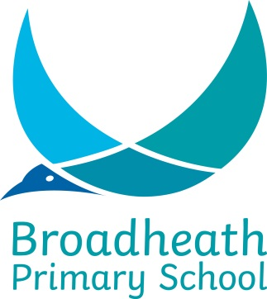
SCHOOL HOLIDAY YEAR SEPTEMBER 2018 / JULY 2019

TERM | SCHOOL OPENS 8.55 am | SCHOOL CLOSES 3.20 pm
Autumn 2018 | Tuesday 4th September | Friday 19th October
 | HALF TERM
 | Tuesday 30th October | Friday 21st December
Spring 2019 | Thursday 3rd January | Friday 8th February
 | HALF TERM
 | Tuesday 19th February | Friday 29th March
Summer 2019 | Monday 15th April | Friday 24th May
 | HALF TERM
 | Monday 10th June | Thursday 25th July

Staff Training Days:

Monday 3rd September 2018
Monday 29th October 2018
Monday 18th February 2019
Friday 26th July 2019
Monday 29th July 2019

