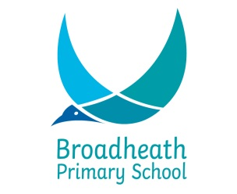

SCHOOL HOLIDAY YEAR 2017 TO JULY 2018

Term | School opens 8.55 am | School closes 3.20 pm
Autumn 2017 | Tuesday 5th September  Half Term  Monday 30th October | Friday 20th October  Wednesday 20th December
Spring 2018 | Wednesday 3rd January  Half Term  Monday 19th February | Friday 9th February  Thursday 29th March
Summer 2018 | Monday 16th April  Half Term  Monday 11th June | Friday 25th May  Wednesday 25th July

Staff Training Days

Monday 4th September 2017
Thursday 21st December 2017
Friday 22nd December 2017
Thursday 4th May 2018
Thursday 26th July 2018

