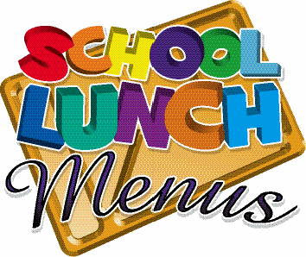

Monday

Week 2

**Fishcake**

**Roast Turkey**

[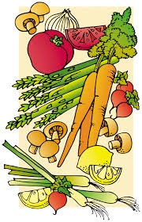](https://www.google.co.uk/imgres?imgurl=https://img.clipartfest.com/8b9b4430f350d8c98de64af8b06aa1db_health-food-for-the-senior-cartoon-food-clipart-chart_2760-4275.jpeg&imgrefurl=https://clipartfest.com/categories/view/e05ed75380a11d4120391406acacc99d92619bfa/cartoon-food-clipart-chart.html&docid=PY93aqGQ4r4IyM&tbnid=K6d3Op4z3BIfvM:&vet=10ahUKEwicl6XbpOzSAhXpL8AKHfinBJAQMwiCAShIMEg..i&w=2760&h=4275&safe=strict&bih=674&biw=1024&q=cartoon%20healthy%20food&ved=0ahUKEwicl6XbpOzSAhXpL8AKHfinBJAQMwiCAShIMEg&iact=mrc&uact=8)

**Friday**

**Thursday**

**Tuesday**

**Wednesday**

**Monday**

**Chicken Curry**

**Carbonara**

**Loaded Burger**

**(Lettuce, tomato)**

Main

**Cheese & Tomato Quiche**

**Veggie**

**Ravioli**

**Tomato & Basil Pasta**

**Quorn veg burger**

**Vegetable**

**Curry**

Vegetarian

Jugs of Water, Yoghurts Daily

**Chips**

**Jacket Wedges**

**Rice and Naan Bread**

**Roast Potatoes**

**Pasta**

Carbs

**Fresh Green Beans**

**Mixed Veg**

**Beans or salad**

**Peas**

**Cauliflower Cheese or Carrots**

Vegetables

[](https://www.google.co.uk/imgres?imgurl=https://img.clipartfest.com/8b9b4430f350d8c98de64af8b06aa1db_health-food-for-the-senior-cartoon-food-clipart-chart_2760-4275.jpeg&imgrefurl=https://clipartfest.com/categories/view/e05ed75380a11d4120391406acacc99d92619bfa/cartoon-food-clipart-chart.html&docid=PY93aqGQ4r4IyM&tbnid=K6d3Op4z3BIfvM:&vet=10ahUKEwicl6XbpOzSAhXpL8AKHfinBJAQMwiCAShIMEg..i&w=2760&h=4275&safe=strict&bih=674&biw=1024&q=cartoon%20healthy%20food&ved=0ahUKEwicl6XbpOzSAhXpL8AKHfinBJAQMwiCAShIMEg&iact=mrc&uact=8)

**Iced Fingers**

**Fruits & Ice cream**

**Orange Muffin**

**Chocolate Biscuit**

**Banana Bread**

Pudding

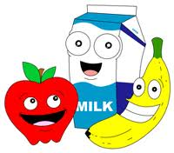

Freshly baked potatoes served with a choice of filling plus salad or hot vegetable accompaniment. The following fillings are served as a daily special:

●Homemade Coleslaw ● Baked Beans ● Cheddar Cheese ● Tuna Mayonnaise ● BBQ Beans

Wraps with salad accompaniment. Serve the following fillings every day, plus the

daily special: ● Egg Mayonnaise ● Tuna Mayonnaise ● Cheddar Cheese

Freshly prepared salad served each day with, tomato, cucumber, lettuce, peppers. Plus daily special:

● Couscous ● Potato salad ● coleslaw rice salad ● pasta salad