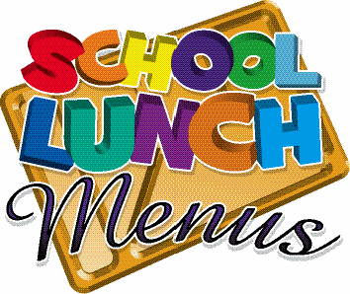

Monday

Week 1

[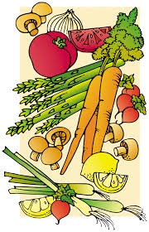](https://www.google.co.uk/imgres?imgurl=https://img.clipartfest.com/8b9b4430f350d8c98de64af8b06aa1db_health-food-for-the-senior-cartoon-food-clipart-chart_2760-4275.jpeg&imgrefurl=https://clipartfest.com/categories/view/e05ed75380a11d4120391406acacc99d92619bfa/cartoon-food-clipart-chart.html&docid=PY93aqGQ4r4IyM&tbnid=K6d3Op4z3BIfvM:&vet=10ahUKEwicl6XbpOzSAhXpL8AKHfinBJAQMwiCAShIMEg..i&w=2760&h=4275&safe=strict&bih=674&biw=1024&q=cartoon%20healthy%20food&ved=0ahUKEwicl6XbpOzSAhXpL8AKHfinBJAQMwiCAShIMEg&iact=mrc&uact=8)

**Friday**

**Thursday**

**Tuesday**

**Wednesday**

**Monday**

**Breaded Salmon or cod & Sweet Chilli Sauce**

**BBQ**

**Chicken Glaze**

**Gammon & Pineapple**

**Meatballs in tomato Sce sauce**

**Cottage Pie**

Main

**Quorn BBQ Fillet**

**Quorn Cottage Pie**

**Quorn Fillet Loaf in Gravy**

**Quorn**

**Meatballs in Tomato Sauce**

**Veg Breaded Grill**

Vegetarian

Jugs of Water, Yoghurts Daily

**Potato**

**Wedges**

**Rice (Savoury)**

**Yorkshire Pudding and**

**Mash or Bread**

**Pasta**

**Roast Potatoes**

Carbs

**Carrots**

**Sweetcorn**

**Green Beans**

**Garden Peas**

**Large Mixed Salad**

Vegetables

[](https://www.google.co.uk/imgres?imgurl=https://img.clipartfest.com/8b9b4430f350d8c98de64af8b06aa1db_health-food-for-the-senior-cartoon-food-clipart-chart_2760-4275.jpeg&imgrefurl=https://clipartfest.com/categories/view/e05ed75380a11d4120391406acacc99d92619bfa/cartoon-food-clipart-chart.html&docid=PY93aqGQ4r4IyM&tbnid=K6d3Op4z3BIfvM:&vet=10ahUKEwicl6XbpOzSAhXpL8AKHfinBJAQMwiCAShIMEg..i&w=2760&h=4275&safe=strict&bih=674&biw=1024&q=cartoon%20healthy%20food&ved=0ahUKEwicl6XbpOzSAhXpL8AKHfinBJAQMwiCAShIMEg&iact=mrc&uact=8)

**Beetroot & Chocolate Muffin**

**Lemon Shortbread**

**Bakewell Tart**

**Mango & Orange Smoothie**

**Fruity Flapjack**

Pudding

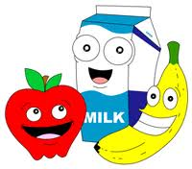

Freshly baked potatoes served with a choice of filling plus salad or hot vegetable accompaniment. The following fillings are served as a daily special:

●Homemade Coleslaw ● Baked Beans ● Cheddar Cheese ● Tuna Mayonnaise ● BBQ Beans

Wraps with salad accompaniment. Serve the following fillings every day, plus the

● Egg Mayonnaise ● Tuna Mayonnaise ● Cheddar Cheese

Freshly prepared salad served each day with, tomato, cucumber, lettuce, peppers. Plus daily special:

● Couscous ● Potato salad ● coleslaw rice salad ● pasta salad